Experiment:11 Date:1/08/2027

To Implement Map Coloring Using Constraint Satisfaction Problem (CSP)

Aim
To develop a Python program to solve the Map Coloring Problem using the Constraint Satisfaction Problem (CSP) approach by assigning different colors to adjacent regions.

Algorithm (Constraint Satisfaction Problem - CSP)
- Read the number of regions.
- Read the names of the regions.
- Read the adjacency information.
- Assign a color to each region.
- Check that no two adjacent regions have the same color.
- If a conflict occurs, try another color.
- Repeat until all regions are colored.
- Display the assigned colors.

Program:

colors = ["Red", "Green", "Blue"]

graph = {}

n = int(input("Enter Number of Regions: "))
for i in range(n):
region = input("Enter Region Name: ")
graph[region] = input("Enter Adjacent Regions (space separated): ").split()
result = {}
for region in graph:
used = []
for neighbour in graph[region]:
if neighbour in result:
used.append(result[neighbour])
for color in colors:
if color not in used:
result[region] = color
break
print("\nColor Assignment")
step = 1
for region in result:
print(f"Step {step}: {region} ---> {result[region]}")
step += 1

OUTPUT:

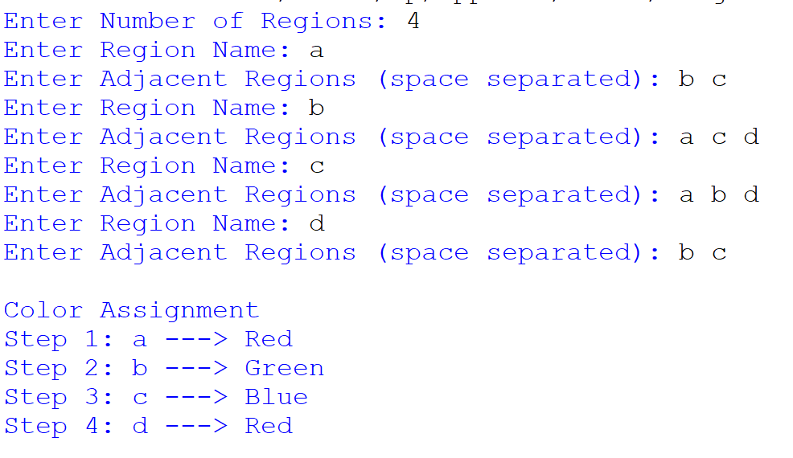

Result
Thus, the Map Coloring Problem was successfully solved using the Constraint Satisfaction Problem (CSP), and different colors were assigned to adjacent regions without any conflicts.

